# PROJECT REPORT

1. INTRODUCTION

1.1OVERVIEW

The urban interior style merges industrial with contemporary design, creating a modern, bohemian look. You'll see concrete floors, exposed timber beams, steel, and unfinished surfaces. Sophisticated finishes and high-end bespoke fixtures makes the Urban look more expensive and polished.

* 1. PURPOSE

Meet Klara Dustin, an accomplished interior designer hailing from St.Louis, Missouri. With a deep understanding of urban living dynamics, she seamlessly combines functionality, comfort, and style, creating personalized havens that truly feel like home amidst city life.

## 2.PROBLEM DEFINITION AND DESIGN THINKING

2.1 EMPATHY MAP

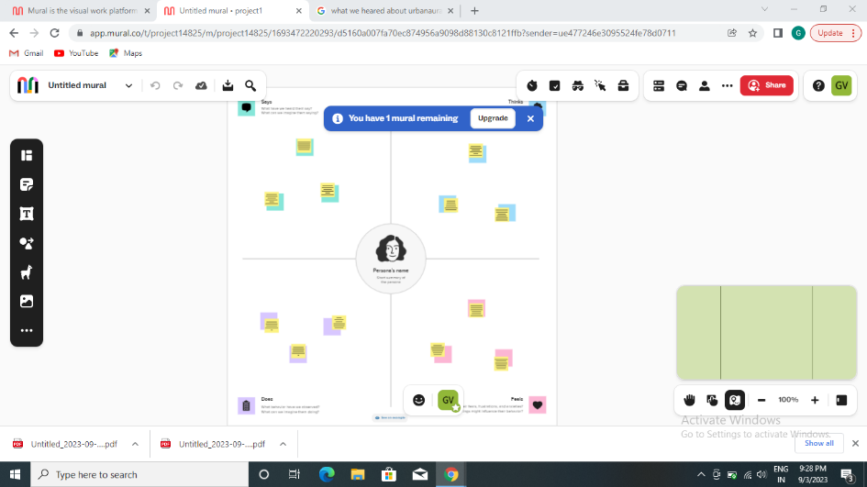

2.2 IDEATION & BRAINSTORMING MAP

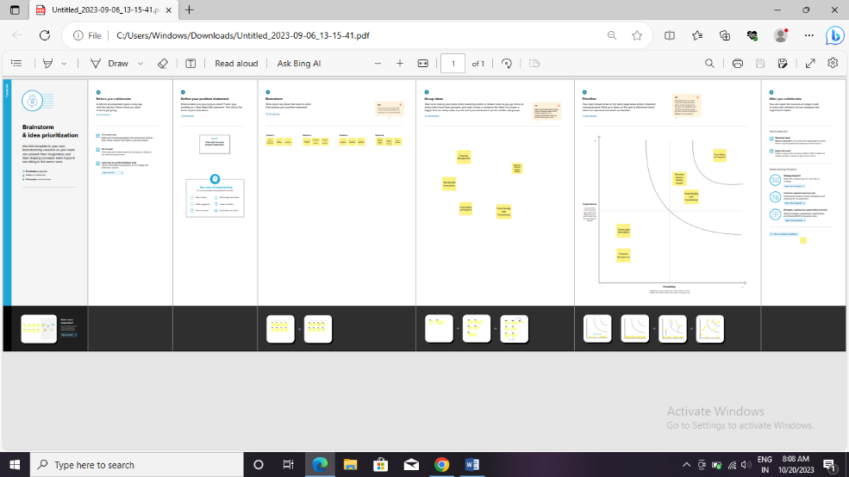

## 3RESULT

BALANCE SHEET

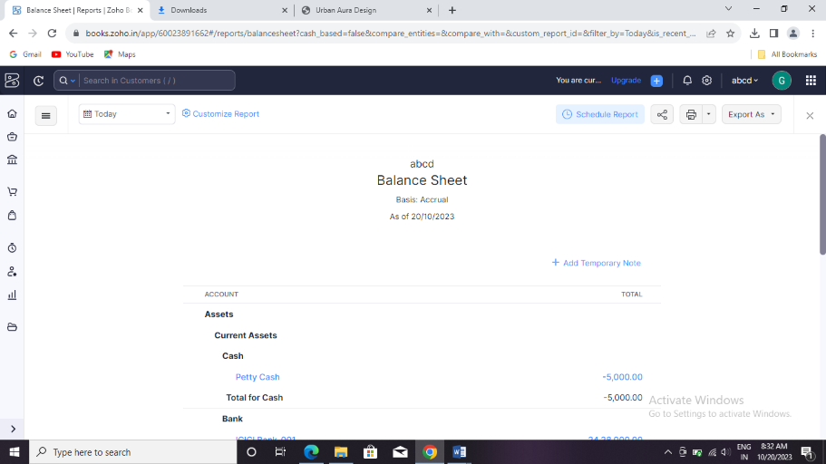

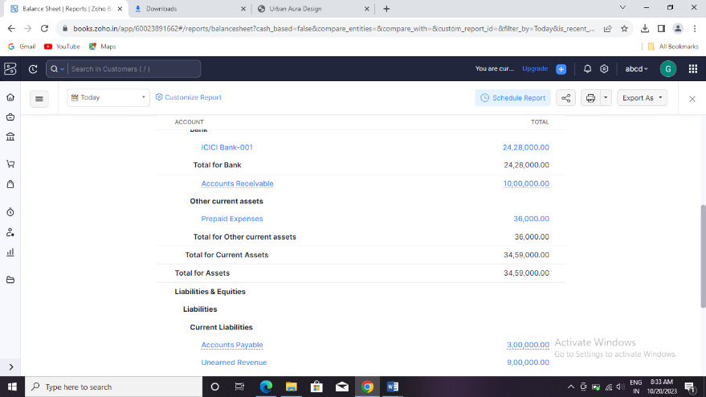

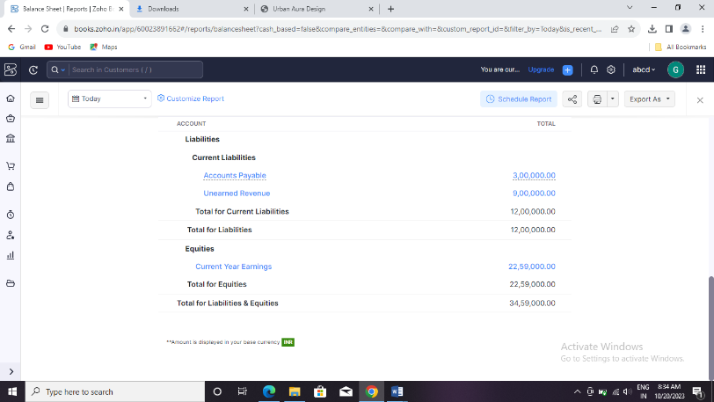

Profit and loss account

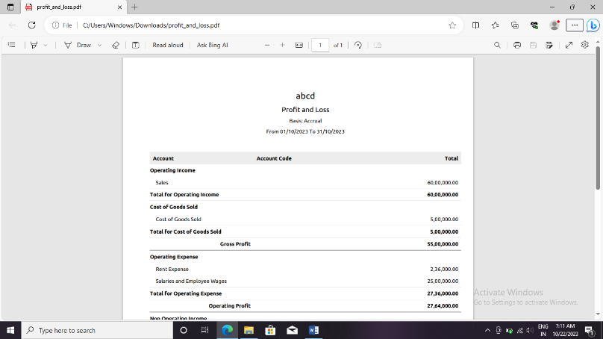

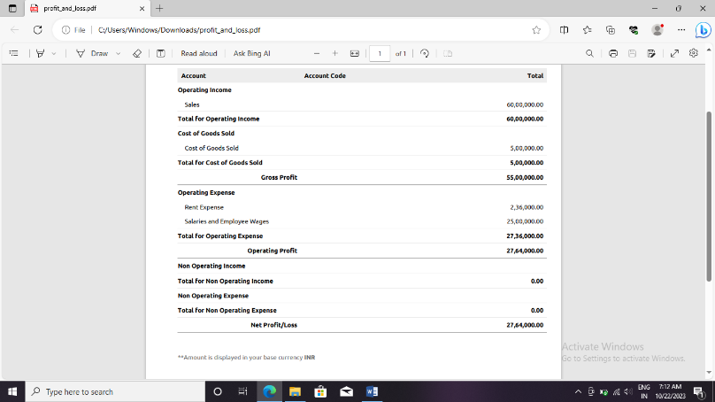

## 4.ADVANTAGES & DISADAVANTAGES

ADVANATGES

* **There are often roads of a better quality and well-built houses in urban areas.**
* **Transport facilities are highly developed and often receive regular funding for updates. It can be faster to get from place to place in a city or town.**
* **Due to better public transport, you can save money on a car**
* **Most amenities and entertainments are easy to reach. Clubs, restaurants and cinemas are more prolific in these busier areas and you often find new attractions will open in a city before anywhere else.**
* **Cities and towns tend to have a greater mix of cultures and ethnicities which can help when making new friends and meeting people.**
* **There are a greater number of jobs available in urban areas. Starting a new career could be far easier if you move to a town or city.**

**DISADVANATGES**

* **Busy towns or cities can feel crowded and may mean you feel more stress or pressure. You may also not be able to form such tight knit communities in urban areas.**
* **Urban areas tend to be more expensive to live in. Property prices are higher and so are goods and services.**
* **Houses are more compact in urban areas. To maximise space, flats and smaller apartments are built instead of houses with larger gardens.**
* **There are often fewer green spaces in a town or city. You may not always be able to enjoy natural spaces.**
* **Public transport might not always be as reliable as you’d like, and many towns or cities are restrictive with parking. If you prefer to drive, you may find it harder to keep a car close to where you live unless it is at great expense.**
* **Because of larger populations, cities can have higher levels of pollution, including noise pollution. This could be damaging to your health in the long-term.**

## APLLICATION

Abstract

As a large proportion of housing stock does not meet the current demands for energy and comfort (leading to high levels of obsolescence and vulnerability), the annual rate of energy upgrades for the existing stock must be increased.

## 6.conclusion

The Solar Decathlon competition assesses comfort in a home exclusively from a quantitative perspective, determining optimal ranges for thermal parameters, humidity, lighting and CO2. However, the AURA Strategy working method understands that the evaluation of comfort should also have a qualitative element.

## 7.future scope

 This article is licensed under a Creative Commons Attribution 4.0 International License, which permits use, sharing, adaptation, distribution and reproduction in any medium or format, as long as you give appropriate credit to the original author(s) and the source, provide a link to the Creative Commons licence, and indicate if changes were made